ARCHITECT REVIEW
SCC-4166 | Mean Time to Repair
Great Plains Merge Sandbox | Local repair and UAT check-only assessment
Source | GreatPlainsMerge | Org 00DEa00000GkAsHMAV | Sandbox
Target | GreatPlainsUAT | Org 00DEa00000FZlLBMA1 | Sandbox
Review date | 26 August 2026
Source retrieval | Succeeded | Job 09SEa00000icqSVMAY
Decision | Changes Requested - do not promote the full scope
Boundary | No deployment, activation, or Salesforce record changes

ARCHITECT DECISION
Do not promote the full SCC-4166 package. The corrected 8-component calculation core passes check-only validation, but the source implementation has two functional defects and the full 13-component scope still fails on five UAT prerequisite/profile errors.

Acceptance outcome
# | Requirement | Result | Evidence
1 | No-work-order MTTR | Partial fail | Numeric formula waits for ClosedDate, but open cases display 0 Hours 0 Minutes instead of blank.
2 | Work-order MTTR | Partial pass | Work Order flow stamps the first Completed/Closed transition and marks the Case as having a Work Order.
3 | Exclude pending-customer time | Fail | Exit branch duplicates the entry condition, so Pending Customer End is never set on exit.
4 | Hours and minutes | Pass | Text formula formats the numeric result as Hours and Minutes.
5 | UAT promotion readiness | Fail | Full scope validates 8/13; two layouts and three profiles fail.

MTTR calculation and control path
SCC-4166 uses two endpoint strategies and subtracts the most recent pending-customer interval. The two red defects below are independent and both must be corrected.
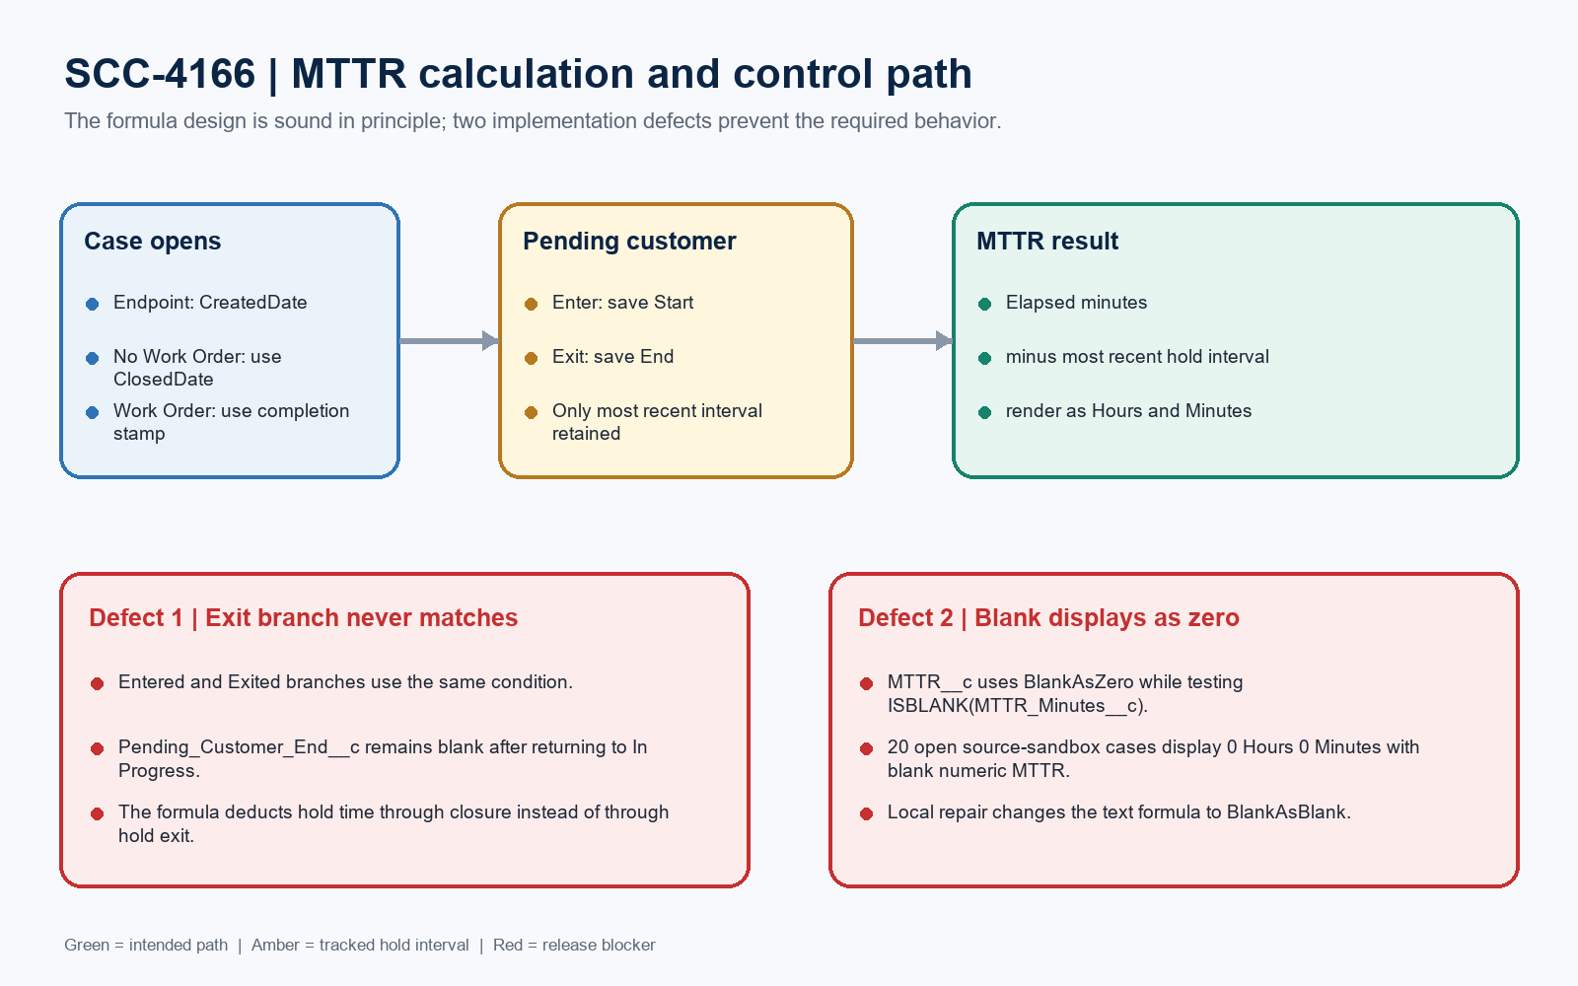
Figure 1. SCC-4166 MTTR calculation and control path
INTERPRETATION
The architecture needs no new code. A surgical Flow condition repair and formula blank-handling correction restore the intended core behavior.

Detailed findings and local repair
Area | Result | Source evidence | Local action
Case hold exit | Blocking | Exited Pending Customer repeats current=hold and prior!=hold. | Change to current!=hold and prior=hold.
Open-case display | Blocking | MTTR__c uses BlankAsZero; 20 existing open Cases show 0 Hours 0 Minutes while MTTR Minutes is blank. | Use BlankAsBlank so the ISBLANK guard returns an empty string.
Work Order endpoint | Pass | Active/latest Work_Order_Update_Case_MTTR_Details stamps the first Completed or Closed transition. | Retain; regression-test both statuses.
Most recent hold only | Pass after fix | Entering hold overwrites Start and clears End, matching the approved most-recent-interval design. | Retain assignment behavior.

Field and automation inventory
Component | Type | Role
Case.Has_Work_Order__c | Checkbox | Set true by Work Order after-save flow.
Case.Work_Order_Completion_Date__c | Date/Time | First Completed/Closed Work Order timestamp.
Case.Pending_Customer_Start__c | Date/Time | Most recent hold-entry timestamp.
Case.Pending_Customer_End__c | Date/Time | Most recent hold-exit timestamp; broken in source.
Case.MTTR_Minutes__c | Formula Number | Elapsed minutes minus most recent hold interval.
Case.MTTR__c | Formula Text | Hours/minutes display; blank handling repaired locally.

COMPONENT-LIST CORRECTION
The story document duplicates MTTR_Minutes__c and omits both active Flows plus Case-Case Layout. The architecture-complete review scope is 13 unique components: 6 fields, 2 Flows, 2 layouts, and 3 profiles.

UAT check-only validation evidence
Scope | Job | Result | Evidence
Corrected core | 0AfEa00000bbRYbKAM | Succeeded | 8/8 components; 6 fields + 2 Flows; 0 tests; checkOnly=true.
Corrected full scope | 0AfEa00000bbRbpKAE | Failed | 8/13 succeeded; 5 errors; 0 tests; rollbackOnError=true.

Five full-scope blockers
Failed component | Validation error
Case-Case Layout | Missing Case.Service_Address__c in GreatPlainsUAT.
Case-Trouble Ticket | Missing Case.Service_Address__c in GreatPlainsUAT.
Admin profile | Unsupported target user permission ArchiveArticles.
Standard profile | Missing Case.Trouble_Ticket record type in GreatPlainsUAT.
System Administrator - API Only | Unsupported target user permission ArchiveArticles.

Evidence boundary
Boundary | Evidence
Source state | Both SCC-4166 Flows are active and latest in GreatPlainsMerge.
Live read-back | 20 open source-sandbox Cases show text MTTR of 0 Hours 0 Minutes with blank numeric MTTR; zero Cases have a pending-start timestamp.
Target read-back | After validation, GreatPlainsUAT still has none of the six fields or two Flows.
No runtime mutation | No Cases, Work Orders, metadata, Flow activations, or org settings were changed.

Required approval gates
Gate | Required action | Owner | Evidence needed
1 | Accept the two local repairs | Solution architect | Review Flow exit logic and MTTR blank behavior.
2 | Promote SCC-3384 prerequisites first | Release manager | Case.Service_Address__c and Case.Trouble_Ticket must exist in UAT.
3 | Replace broad profile payloads | Security owner | Use a focused permission set or retrieve target-aligned profiles; remove unrelated ArchiveArticles drift.
4 | Rerun full validation | Release manager | Require 13/13 success before any deployment approval.
5 | Run business tests | QA | Capture Case/Work Order IDs and field read-back for both endpoint paths.

Business-user regression sequence
Test | Path | Steps | Expected
A | No Work Order | Create Trouble Ticket; set In Progress; enter hold; exit hold; close Case. | MTTR is blank until Closed and excludes only the hold interval.
B | With Work Order | Create Work Order; move to Completed; leave Case open. | Has Work Order=true; completion timestamp set once; MTTR populated.
C | Repeated hold | Enter/exit hold twice before closure. | Only the second interval is excluded, per approved design.
D | Negative regression | Open Case with no completion endpoint. | MTTR text and minutes are both blank, never 0 Hours 0 Minutes.

Ready-to-paste architect response
STORY COMMENT
Architect review completed in GreatPlainsMerge with check-only validation against GreatPlainsUAT. Changes Requested: the active Case before-save Flow has a duplicated pending-customer entry condition, so the exit timestamp is never set, and MTTR__c treats blank numeric MTTR as zero; 20 open source-sandbox Cases currently display 0 Hours 0 Minutes. I prepared local surgical repairs for both defects. The corrected 8-component core passes check-only validation (job 0AfEa00000bbRYbKAM, 8/8). The corrected full 13-component scope remains blocked (job 0AfEa00000bbRbpKAE, 8/13) because UAT lacks Case.Service_Address__c and Case.Trouble_Ticket, and the broad profile payloads contain ArchiveArticles drift. Deploy SCC-3384 prerequisites first, replace or trim the profile changes, rerun 13/13 validation, then execute the four business tests. No metadata, activation, settings, or records were changed.

